

Ultimate User Guide
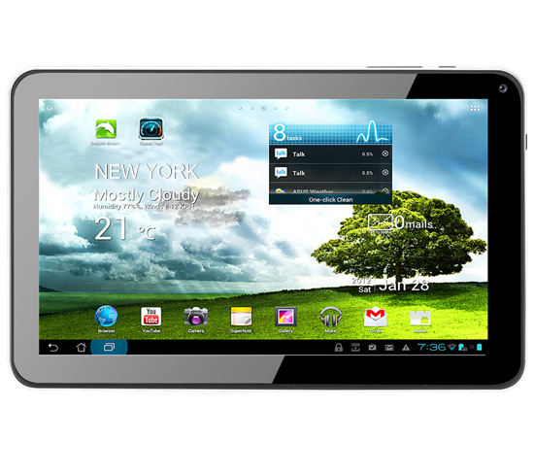

Table of Contents

Setting Up Your Tablet

Full Charge ................................................................................................ 1

Power On .................................................................................................. 1

Touch Screen ............................................................................................ 2

Google Account ......................................................................................... 3

Set Up Wi-Fi .............................................................................................. 4

Android Settings ........................................................................................ 4

Configure Email ......................................................................................... 6

Sending Emails ......................................................................................... 8

Browse the Web ........................................................................................ 9

Using the Image Gallery .......................................................................... 10

Changing the Wallpaper .......................................................................... 12

Homescreen Folders and Shortcuts ........................................................ 13

Android Widgets ...................................................................................... 15

Maintain and Protect Your Tablet

Increase Battery Life ............................................................................... 17

Protecting Your Tablet ............................................................................ 18

Reset Your Tablet ................................................................................... 20

Android Tips

Alternative Keys ...................................................................................... 21

Android Version ...................................................................................... 21

Bigger Battery Graph .............................................................................. 21

Cut and Paste ......................................................................................... 21

Force Stop .............................................................................................. 22

Fifteen Minute Refund ............................................................................. 22

Warranty and Support ............................................................................. 23

Full Charge

When you first open your Android tablet, give it a FULL charge BEFORE using it (5 hours is the perfect amount of time). Turn on the tablet and go to “Settings” and then “Battery” and check to see that the battery level is 100%.

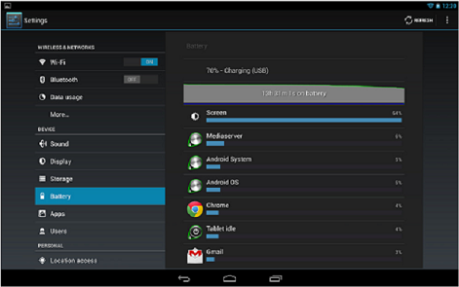

When it has reached 100%, unplug the tablet, turn it off, and then back on again, and plug the charger back in. This will reset the battery level indicator and show you the true battery level (which may be less than the 100% it previously showed).

Also, try to let your tablet battery get down to under 10% before charging, and then charge it back up fully (4-5 hours) rather than charging it for an hour just so you can use it again sooner.

Finally, it is best never to allow your tablet to discharge fully, and sit for any length of time discharged. This could kill the battery so that it no longer holds a charge. In other words, “Use it or lose it” is a good rule with your tablet.

Power On

To power your tablet up, find the power button (you can tell it’s the power
page 1
button from the symbol directly behind it on the back of the tablet):
Press and hold the power button in for 3-5 seconds, or until the screen comes to life. The tablet will take 1-2 minutes to “boot” to the home screen where you can start to use it.

Touch Screen

Touch
The touchscreen is sensitive to the tiny electrical charge in our bodies. This means you only have to tap the screen, not bang down hard with your finger. To activate items on the screen such as applications and settings icons, to type letters and symbols using the onscreen keyboard, or to press onscreen buttons, you simply (and gently) touch them with your finger.

Touch and Hold
Touch and hold is useful in a number of different situations. You can touch and hold an item on the screen by touching it and not lifting your finger until an action occurs. This can be a menu opening or an icon lifting off the screen to show that it can be moved.

Drag
To drag items around the home screen, touch and hold an item for a moment and then, without lifting your finger, move your finger across the screen until you reach the desired position. Lift your finger off the screen and the item will drop into that location (if the location is free). You can drag items on the home screen to reposition them, and you can drag down the screen to open the Notifications panel.

Swipe or Scroll
Many of the menus or web pages that you can access on Android require you to scroll. To swipe or slide, quickly move your finger across the surface of the screen, without pausing when you first touch it.

Double Tap
There are several places where a double-tap results in an action. Tap quickly twice on a web page or other screen to zoom.

page 2
Pinch to Zoom
In some applications (such as browser and gallery) you can zoom in and out by placing two fingers on the screen and pinching them together to zoom out) or spreading them apart (to zoom in).

Google Account

You may already have a Google (or gmail) account. If you don’t, you will need to set one up. It’s free, and you will need it in order to access the Google Play Store (for downloading apps), and can also check your emails right on the tablet. It will probably be easier (although not absolutely necessary) to set up your account on your PC or laptop than on the tablet.

To set up your new Google account, go to https://www.google.com/accounts/NewAccount and fill in all the required details.

Once you have your Google account login details, you can add it to your tablet by going to:

“Settings” > “Accounts & Sync” > “Add Account”

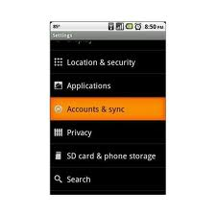

Once you have your Google account set up on your tablet, you are one step closer to enjoying it to the fullest.

page 3
Set Up Wi-Fi

If you have a Wi-Fi router at home, it’s a good idea to set up your tablet to connect to this by default.

1. From your tablet’s home screen, click on “Settings” and then turn on the Wi-Fi. It should scan all of the nearby connections available to you, and as long as your router is turned on, yours should be one of the networks listed.

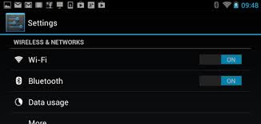

2. Select you network and enter the password (unless you have an unprotected network, which is not recommended), and the tablet should automatically connect to that Wi-fi network, as long as it is within range.

* If the tablet shows that you are connected but you cannot access the internet, then tap on the network name and check to see what your network is “Secured With”. If it says WEP, then you will have to contact your provider and have them switch your security setting to WPA/WPA2/PSK (this does not cost you anything, nor do they have to come to your home to switch it over). Once they do, you will be able to access the internet, Playstore, and other apps that require internet connection.

Android Settings

You can access the tablet’s menu by tapping on the 6 white squares on the top right of the home screen. Accessing this feature at any other time (for example if you have an app open) will display a different set of options specific to that app.

page 4

Wi-Fi
In this section you will find the on/off switch for the wi-fi. Once turned on, you will see other options and features to the right.

Data Usage
Most of our tablets are “wi-fi” tablets that do not accept a sim card, and so there will be no data usage shown in this setting. You will still use data on your network, but the tablet will not reflect that usage. If you have one of our 3G tablets, this setting will show the data used for the data usage cycle.

More
- Airplane Mode - check the box to temporarily disable the wi-fi
- Ethernet - access this setting to connect an Ethernet cable where wi-fi is not available

Sound
The sound menu gives you access to default notification sounds, and volume control for music, video, games, notifications and alarm.

Display
You can set the brightness, wallpaper, auto screen rotate (on/off), sleep delay, font size, and a couple other options related to your screen display.

Storage
Here you can see how much storage space your tablet has as well as what is using storage space (apps, music, etc.). Tap a category to see a list of items with their file size. For certain items such as downloads and cached data, you can select them and delete them from the tablet here.

Battery
Shows information on battery usage and how full it is charged

Apps
Here you can see a list of apps that are “Downloaded”, “On Storage” or “Running” and manage each app individually by clicking on them. Here’s where you can uninstall downloaded apps, or force stop running apps, etc.

Accounts and Sync
Add or remove email accounts on your tablet
page 5

Location Services
Not applicable on our tablets

Security
Secure your tablet with a password, code or PIN

Language and Input
Change the language of your tablet

Backup and Reset
Restores the tablet to the original factory settings. You can choose to back up your data before this reset, or erase everything (except what the factory pre-installed) and start from the beginning as if you just opened the tablet for the first time.

Date and Time
Change the date, time and time zone on your tablet

Accessibility
Control the text size, screen rotation, and a couple of other options

Developer Options
Contains a number of controls rarely used by the average user.

About Tablet
Shows a variety of information about the tablet, such as OS version, build number, etc

Configure Email

Being able to easily sync your Gmail account to your Android tablet is great, but there are sure to be lots of users who use different email accounts. Setting up your tablet to pull emails from these POP3 or IMAP accounts is relatively easy, but you will need your user name and password details, as well as the names of you incoming and outgoing mail servers. You can usually find this information in the account settings of your current email program (Yahoo, Hotmail, etc.), but if not you will need to contact your ISP.
page 6
Step 1
Open the email app from the All Apps menu on your tablet and enter your email address and the password for that email account. If you don’t know the password, contact your ISP.

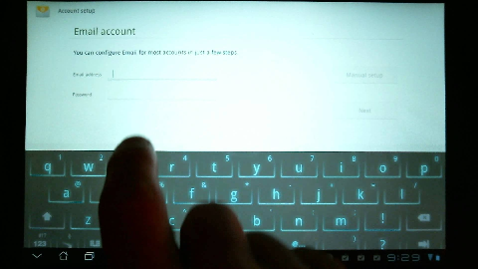

Step 2
Touch Next and choose the type of email account you use (POP3, IMAP or Exchange). IMAP is generally better as this type of account keeps the message on the server after reading on your tablet.

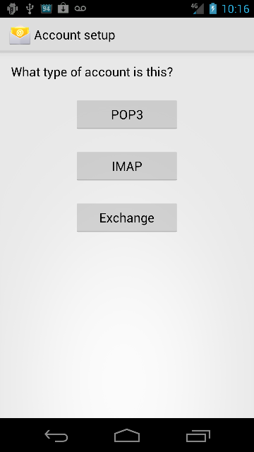

Step 3
The settings should be pre-filled for most of the major ISPs. Tap Next and let the client attempt to automatically configure the incoming server settings. Repeat for the outgoing settings.
page 7
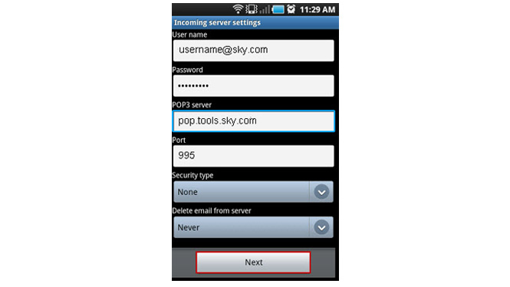

Step 4
If the automatic setup fails, you will have to use the manual setup and enter your email, password and the server details in the boxes provided. You may need to change the security type to SSL/TLS.

Step 5
On the next screen you can change some of the account settings. These include the frequency at which the app checks for new emails on the server and whether notifications are turned on.

*To add a second, third or fourth email account, press the menu button and select New Account. You will be taken back to the account setup screen where you can add your additional account details.

Sending Emails

If you are not used to using your tablet to send and receive email, getting started can seem a bit if a chore. By following this essential guide, you will learn how to compose, send and receive, and configure your emails.

Step 1
Open the Email app from either the shortcut on the homescreen or by browsing to the main apps menu.

page 8
Step 2
If you want to reply to an email you have received, touch the email in the list and then click on the reply button at the bottom of the screen.

Step 3
If you want to compose a new email, press the menu button and click on Compose from the menu that pops up.

Step 4
You can now either tap the contacts icon to find a contact in your main list, or enter the email address manually in the To box.

Step 5
Add a subject, then tap the main message box and start to type your email message.

Step 6
When you are finished tap Send. You can also choose to Save as Draft if you don’t want to send it right away.

Browse the Web

Assuming you have access to a decent wi-fi connection, one of the first things you will probably want to do on your new Android tablet is browse the internet. This guide will lead you through the basics of viewing websites on your Android tablet.

Step 1
To open the browser, find and tap the Browser icon on the desktop or in the main apps menu. If there isn’t a shortcut to the browser on the homescreen, it is a good idea to add one.

Step 2
The browser will open to the Google Search website. At the top of the screen you will see the address (URL) of the website you are on. To go to other websites, touch the address bar and delete whatever text is in there. You can now type an address if you know it.

page 9
Search History
Each search you enter into the browser is saved in the search history. The next time you search for something, a list of your previous searches will pop up as search suggestions. You can clear your search history in the browser settings (Menu button > Settings > Privacy and Security > Clear Browser History).

Google Search Widget
A very quick way to start an internet search is to use the Google Search Widget installed on your tablet. When you add the widget to your homescreen you have the option to search everything on your tablet, or individual areas (Internet, Facebook, Contacts etc.). Set this to internet, type your search term and tap the arrow button. A Google search results page for the searched term will automatically open.

Bookmarking Pages
To bookmark any web page, simply navigate to the page and then tap the star in the URL box. The bookmark edit box will open allowing you to rename the bookmark and choose where it is saved. You can save shortcuts to your bookmarked websites directly on the homescreen. To do this, go to your bookmarks from the browser (tap on the small black star). Find the bookmark you want to save to your desktop, and press and hold. A box will appear, and you can choose Add Shortcut to Home.

Using the Image Gallery

The Gallery app on your Android tablet is the central repository for any images and videos you create, download or capture with your camera. You don’t need to choose to send an image to the gallery, it is all done automatically. The Gallery app will also automatically sort your images into separate folders such as All Photos and All Downloaded.
*If your tablet does not have a gallery app, we suggest downloading Gallery ICS from the Playstore.

Albums as Slideshow
You can view any album as an automatically scrolling slideshow. To do this, open any album and press the menu button. Select slideshow from the menu. The images will now zoom to full screen and start scrolling through.

page 10
Browsing the Gallery

Step 1
The Gallery app can be opened either from the main apps list or a shortcut on the homescreen if you have one.

Step 2
Choose the album you want to view from the list on the main screen. Certain apps create albums, so the amount shown will vary.

Step 3
The default view option is grid view, but you can change this to filmstrip view using the tab at the top of the screen. To scroll through the images in filmstrip, slide your finger left or right.

Step 4
If you want to zoom in on an image, tap the image in the gallery and then pinch to zoom. Tap the image again or tap Back to return to the scrolling gallery.

Step 5
To edit any image, press the menu button and select Edit. Now scroll to and tap the image you want to change. You can crop, rotate and change the brightness of an image, as well as add filters.

Sharing Images
You can share any of the images in your albums via the usual methods (email, Facebook, SMS, etc.)

Step 1
Open the gallery app and select the album that contains the image you want to share. Once you have scrolled to the image, tap the Share button at the top of the screen.

Step 2
A list of the available sharing options will then appear. This will vary depending on what apps you have installed, but will always show email, Facebook, etc.

page 11
Step 3
Complete whatever action is needed to send the image. If sending with email, write a message. If adding to Dropbox or Google Drive, confirm the images selected.

Changing the Wallpaper

Just about the easiest and quickest way to add a bit of personality to your Android tablet is to change the background wallpaper. There are several different options to choose from when it comes to wallpapers, and you aren’t stuck with those already installed on the device.

Step 1
Touch and hold on any free area of the homescreen until a window pops up and then choose which type of wallpaper you want. Options will include Live Wallpapers, Wallpapers and Gallery.

Step 2
Choose the type of wallpaper you want, and then scroll through the list of options to find the one you like. Touch Set Wallpaper to select it and set it to the homescreen.

Step 3
An alternative way to set the wallpaper is to open the Image Gallery app and browse through your saved images until you find one you would like to use.

Step 4
Click on the one you like, preview it and then press the Menu button. From the action menu, select Set Picture As and then choose Wallpaper.

Step 5
Before the wallpaper is applied, you can crop the image by dragging the edges of the blue box that appears.The box shows how the image will look in portrait and landscape. When you are happy, click Save.

Image Size and Shape
When choosing an image to use as your wallpaper, bear in mind it should be a reasonable size and wider than it is tall. When you scroll through your
page 12
homescreen panels, you will notice that the wallpaper moves as well. This means that ideally wallpaper should be slightly wider to accomodate this movement. This isn’t a hard and fast rule, but it will help to stop the background image from being stretched.

Choosing Images
Bear in mind that not every image is suitable as wallpaper and choosing the wrong image can make finding icons on the homescreen difficult. Darker images are thought to help improve battery life (VERY slightly) as the display does not have to work so hard lighting up pixels.

Finding New Wallpaper
You can use any image as the wallpaper on your tablet, from a photo you take on your tablet’s camera, from pictures downloaded from the internet. A quick search on the Google Playstore will give you access to hundreds of static and Live wallpapers.

Live Wallpapers
Android’s Live wallpapers look very nice and, despite the fact that they don’t help the battery life of the tablet, almost all new users will want to play around with them. A well-made Live Wallpaper should be smoothly animated and may even include interactive animations when you tap the screen (ripples in water where your finger touches, etc.).

Homescreen Folders and Shortcuts

Folders are very useful for keeping your homescreen organized and to give you more room for widgets. A folder lets you group multiple shortcuts together in a single place, just like a folder on the desktop of a PC. You could have a folder for Direct Message shortcuts, one for Game shortcuts and another fir Business App shortcuts. This allows you to have dozens of actions within easy reach whilst using up a fraction of the space needed if they were all loose on the homescreen.

Creating Folders
You can create as many folders as there are spaces on the homescreen. You can’t however, place folders inside other folders, nor can you move widgets into folders.
page 13
Step 1
Folders are created automatically when you move one shortcut over the top of another. Tap and hold on a shortcut and drag it directly over another shortcut.

Step 2
You should see that a black circle appears behind the bottom shortcut. This means that a folder is ready to be created. Take your finger off the screen and a folder is created with both icons inside.

Step 3
Tap the folder to open it and then touch your finger on the title bar (which will say “Unnamed Folder”) to change the name of a folder.

Step 4
The name of the folder will now be displayed below it when it is not open. You should notice that unnamed folders do not show any title at all.

Step 5
If you want to take something out of a folder, open it and touch and hold your finger on the shortcut. Drag the shortcut out of the folder and onto a free area of the homescreen.

TIP: When creating folders, it makes sense to give them a name that you will understand at a later date. “Mixed Media Apps” makes much more sense than “MMA”, particularly if you plan to have a lot of different folders on the homescreen.

Crating Shortcuts
Anyone who has used a pC or a MAC should be familiar with shortcuts. Homescreen shortcuts are simply small icons which give you direct access to an application or function on your tablet without having to search through the app menus each time you want to use it. Adding shortcuts to the homescreen is incredibly easy.

App Shortcuts
To add an app shortcut to the homescreen, open the main app menu to display all of your apps. Touch and hold on the one you want to move until the homescreen reappears. Drag the icon to the location you want it and
page 14
drop it into place. By default, every new app you download from Google
Play will have a shortcut added to the homescreen. If you want to stop this from happening, open the Play Store app, tap the menu button and select settings. Uncheck the Auto-add Widgets box. New app shortcuts will now only appear in the app menu until you choose to move them.

Website Shortcuts
Another useful way to use shortcuts is to create homescreen shortcuts to your favorite websites. Think of it as the ability to have browser bookmarks on the homescreen. To create a website shortcut, open your favorite website in the browser and then save it as a Bookmark. Tap the menu button and select Bookmarks from the menu. Touch and hold on the one you just added and then select Add to Homescreen from the pop-up menu.

Removing Shortcuts
You can remove shortcuts from the homescreen at any time simply by touching and holding on them until they lift off the background, and then dragging them to the top of the screen where the word Remove will have appeared. If your shortcuts are in a folder, you can the whole folder in the same way and remove all shortcuts in one go. When you remove a shortcut, you aren’t removing the app. You will still be able to find it in the main app menu.

Android Widgets

Widgets are one of the features that makes Android such a user-friendly operating system.

What Are Widgets?
Widgets are a bit like mini applications that sit on the homescreen and display various bits of information from the main application. Think of it in terms of a house, your tablet being the house, the apps are the rooms in the house and widgets are the windows. Rather than having to go in the front door, finding a room and looking inside, it is easier to just look through the window.
An example is the email widget. Of course, you can use a shortcut to open the email app every time you get a new message, but by adding an email

page 15
widget to the homescreen, you can see the latest message without having to
open the app at all. If you need to reply to the message, a button on the widget lets you instantly open the compose email screen.

Adding a Widget - Ice Cream Sandwich

Step 1
Touch and hold your finger on any empty area of the homescreen until a menu appears.

Step 2
From the options, select Widget to open a full list of all the available widgets and the apps they relate to.

Step 3
Tap the widget you want to add. If there are style options, you will then be given a chance to choose which one you want to use.

Step 4
When you are happy with your choice, touch the Select button to add it to the homescreen.

Adding a Widget - Jelly Bean

Step 1
Open the main apps menu and scroll across to the last page of apps. Scroll right once more and the widgets menu will open. There will probably be several pages of widgets already there.

Step 2
Find the widget you want to add and hold your finger on it. The screen will then flip back to the homescreen with the widget still held. Without letting go, move the widget to where you want it.

Step 3
As you move widgets around the screen, the shortcuts and widgets already present will shift and move to accommodate it. When you are happy with its position, lift your finger off the screen.

page 16
Step 4
Some widgets can be resized to be a better fit. To do this, touch and hold the widget again until it is highlighted. Drag the edges of the highlighted box to resize the widget.

Removing Widgets
On both OS versions, you can remove a widget as easily as moving one. Hold your finger on the widget until it lifts off the screen. Drag the widget to the top of the screen where the word Remove will have appeared. Release the widget and it will have been removed from the homescreen, but will still be available in the main Widgets menu where you found it.

TIP: A great widget to start with is the Power Control widget. This gives you a useful set of homescreen buttons with which you can turn on/off Wi-Fi, as well as allowing you to quickly change screen brightness.

Maintain and Protect Your Tablet
We are sure that you will want to keep your shiny new Android tablet running as smoothly as possible, and for as long as possible. Our maintenance guides will show you the best ways to prolong the battery life, protect your tablet from prying eyes, reduce data usage and create a full backup. As if that wasn’t enough, we have included dozens of useful mini tips that will help to make using your tablet easier.

Increase Battery Life
Short battery life has been a drawback of all tablets for almost as long as they have been around. The problem seems to be a never-ending one. There are, however, several things you can do to increase the length of time between charges.

Adjust the Backlight Brightness
One of the quickest and easiest ways to save some battery juice is to turn down the brightness of the screen backlight. Open Settings > Display > Brightness and then move the slider down to wherever you think it is acceptable. Less than 50% is advised.

page 17
Power Control Widget
If you haven’t already, get the Power Control widget onto the homescreen. While this doesn’t actually save any battery life, it does help you to keep an eye on power-hungry things like Wi-Fi. It also allows you to adjust the brightness easily without having to go into Settings.

Change the Wallpaper
Getting rid of your lovely Live Wallpaper isn’t going to give you an extra 24 hours for watching videos, but it will make a slight difference if your tablet is really struggling to last very long. And if you’re changing to static wallpaper, choose a dark (preferably black) one. The pixels in the screens are photoemissive. This means that they generate light. Having a black background allows the pixels to effectively turn themselves off.

Decrease Screen Timeout
Again, this will not save massive amounts of power, but every little bit helps. And do you really need you screen to stay on for 10 minutes after you finish using the tablet? You can switch off the screen manually before you put your tablet in your bag, but each time you get a notification or a message and then don’t check it (or don’t hear it) your screen will stay on for whatever period is set.

Turn Wi-Fi Off
Turn Wi-Fi off when you don’t need it. Go to Settings > Wireless and Networks and turn the switch to the Off position.

Protecting Your Android Tablet

More and more often we are using our Android tablets to store dozens of passwords and usernames, banking details, emails and other valuable information. You might also have hundreds of important photos and images, documents or contact details. As soon as you start adding this sort of information to your device, you need to start thinking about protecting the tablet and its contents.

Physical Damage
The cheapest and quickest way to protect your tablet from knocks and

page 18

scratches is to keep it in a protective case. Dropping and breaking your delicate tablet can be, at best, inconvenient. Your problem can become more expensive if you don’t have accidental damage insurance.
Square trade is just one of the accidental damage insurance providers you can look into at www.squaretrade.com. If you do not have insurance, we have a program unique in the tablet industry where, as long as you are within your 1 year manufacturer’s warranty, you can contact us directly, and, for a nominal fee, we will replace the tablet for you. Please see our contact info on the last page of this guide.

Prying Eyes
To lock your tablet so that you are the only one who can access it, go to Settings > Security > Screen Lock and then choose Pattern. You will then be shown how to set up and use a Pattern Lock. You can, if you wish, choose instead to use a PIN or traditional Password to unlock your tablet when in the Screen Lock menu.
You will be able to choose the period of inactivity before the tablet locks (immediately, 3 minutes, 5 minutes, etc.) as well as other options such as whether the pattern is visible on screen when you input it (choosing invisible pattern adds more security as it reduces the chance of someone seeing and being able to copy the pattern).

Malware and Viruses
The issue of Malware and viruses infecting Android devices is, thankfully, a small one. There have only been around 100 know malicious apps for Android, out of 700,000+ apps available on Google Play. Nevertheless, it is a good idea to prepare against possible malicious attacks on your tablet in the future. Here are some top tips to help keep your tablet free from malware and viruses.

1. Research apps before you download. Always read as much as you can about an app before installing it, and not just the app info page on Google Play. Have a look at the comments and reviews from users, both on the Play Store and on other reputable sites or in magazines. Visit the developer’s website and see what other apps they have developed.

2. Check Permissions. This is something that many people probably do not routinely do, but it can be a good indicator of a suspect app. A casual game
page 19
app, for example, probably shouldn’t need to access your email or contacts. If you think an app is asking permission to do more than you think it needs to, pass on that app.

3. Don’t install APKs (Android Package Files). There are certain apps that are initially only available as an APK from a third-party (ie. unofficial) source. This method of directly installing apps, sometimes called Sideloading, is not recommended. You just never know what is included in the file until, perhaps, it is too late.

4. If in doubt, move on. If you are not 100% sure that an app is safe to install, don’t install it! There are very few completely unique apps out there, so in most cases you will be able to find a reputable app to do the task you require.

5. Install an anti-Malware app. There are several such apps, from big name security software companies, available on Google Play. The risk might be small now, but due to the Open Source nature of Android and the lack of restrictions to adding an app to the Play Store, the problem could get worse in the future. Two of the most popular are Anti-Virus Free and Lookout Mobile Security.

Reset Your Tablet

There are several reasons why you may want to reset your Android tablet, from trying to fix sluggish apps to wiping the tablet if you are thinking of giving or selling it to someone else. There are two different ways to reset your tablet, Soft Reset and Hard Reset, and it is important you know what effects each one has.

Hard Reset (Factory Reset)
If you’re passing your tablet on to someone else or your tablet has a persistent probelm that cannot be solved, you can do a factory reset (also called a hard reset). This returns you tablet to the state it was in before the first time you turned it on (assuming you bought it new).
Factory reset is not a step to be taken lightly. It will permanently delete all your data and customized settings, and will also remove any applications you’ve downloaded and installed.
The simplest way to perform a factory reset is through the Settings menu. Go
page 20
to Settings > Factory Data Reset. On the right hand screen select Factory Data Reset, then select Reset Tablet, and, finally, Erase Everything. Once the tablet has restarted you will need to enter your Google account, Wi-Fi password, etc., so make sure you know them and have them on hand.

Soft Reset
To soft reset your tablet basically means switching it off and on again. Switching off your tablet from time to time can help if your apps start to run
sluggishly or the general performance of the tablet is starting to dip. The

action of switching off your tablet allows apps and services to reset to their boot-up state. We recommend doing this every once in a while.

Android Tips

It can take a while to fully understand the Android operating system, and without a little help many of the little tricks and hidden features can remain a mystery. This collection of Android tips is your shortcut to making your device work the way you want and need it to. Even experienced Android users will find a few pearls of wisdom they didn’t know about.

Alternative Keys
Some keys can display more than one symbol. You can long press the key and swipe over one of the symbols that popsup to insert it. For example, press and hold “a” and you can choose from these options:

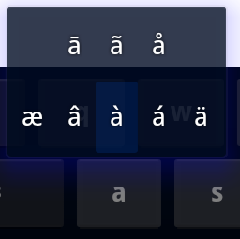

Android Version
You probably already know what version of Android your tablet is running, but if not, and if you wish to know, you can have a look in Settings > About Tablet > Android Version.
page 21

Bigger Battery Graph
For a more detailed analysis of how your battery is doing, go to Settings > Battery to see how much time the battery has been working and how the power consumption is divided up.

Cut and Paste
Need to cut and paste text? Long-press on any text input area and select Cut or Copy from the action menu. If you’re on a web page, tap the Menu key and choose the select text option. You can also choose to highlight selected text fro the Action menu.

Force Stop
From time to time your apps may freeze up or stop working as they should. There can be several reasons for this, but a good way to test if this is a major problem or just a glitch is to force the app to stop and reset itself. Press the Menu button and choose Settings. Select Apps from the list and view the Running Apps. Select the app in question and tap the Force Stop button. You can then try to start the app again and see if the problem is gone.

Fifteen Minute Refund
When you purchase apps from Google Play, you have 15 minutes from the time of download to return an application for a full refund. You may only return a given application once. If you subsequently purchase the same app again, you may not return it a second time. If you’re unsatisfied with an application after the 15 minute return period has expired, we recommend contacting the developer directly.

page 22
Warranty and Support

Warranty
Your Kocaso Android tablet includes a limited 1 year warranty. The warranty is honored as a direct exchange with our company. For this item there is no written warranty or forms to fill out. Should there be any issue within this time period please let us know and we will assist with troubleshooting, or a return if necessary.

Before you return your tablet, however, you will want to contact us to troubleshoot the issue you are having. There may be a solution that we can help with without you having to return it. If we decide that a return is necessary, we will issue an RMA (return merchandise authorization) number to you so that the replacement process goes quickly and smoothly.

To contact us, you may go to www.kocaso.com and click on the CONTACT link at the top of the home page. PLEASE fill in all of the fields so that we may best help you. We will need to know where and when you purchased it in order to determine the warranty status, as well as your email address and phone number so that we can respond.

***The warranty does not cover such things as physical damage (cracked screens) or water damage. There are extended “accidental damage” warranties available on the market (Square Trade is one of the more popular ones) that will cover this type of damage. If you damage the screen on your tablet and did not purchase an accidental damage policy, we have a tablet replacement program where, for a nominal fee, we will replace your tablet with a non-damaged working one within days. This program is only offered if you are still within the 1 year manufacturer’s warranty period.

Support
Also on our web site, ww.kocaso.com, you may click the SUPPORT link to find PDF manuals for the specific models, get the latest firmware update for your tablet, and watch video tutorials on how to use your tablet.

Thank you for choosing Kocaso as your brand of tablet.

page 23

